TEST REPORT FOR GUI IPERF TOOL

The GUI-based iPerf performance tool was tested comprehensively to evaluate its functionality, reliability, and usability in conducting network performance measurements. The application provides a graphical interface to configure and execute iPerf tests, allowing users to run both TCP and UDP throughput assessments between client and server machines. During testing, the GUI successfully facilitated the setup of test parameters such as target IP address, port number, test duration, and bandwidth limits, while also validating input to prevent invalid configurations. The iPerf backend was correctly invoked from the GUI, and test results—including bandwidth, jitter, and packet loss—were accurately displayed in real-time. Both functional and negative tests were conducted to ensure stability; the application remained responsive even during long-running tests, and error conditions were handled gracefully, with informative messages displayed to the user.
Performance metrics observed aligned with expected network conditions, demonstrating the tool’s reliability in measuring network throughput. Additionally, logging and reporting features were verified, confirming that test results could be stored for future analysis. Minor usability improvements, such as more intuitive button labeling and progress indicators, were identified but did not impact the core functionality. Overall, the application proved to be a stable and user-friendly tool for network performance testing, combining the accuracy of iPerf with the convenience of a graphical interface.
This is the interface when we open the application –
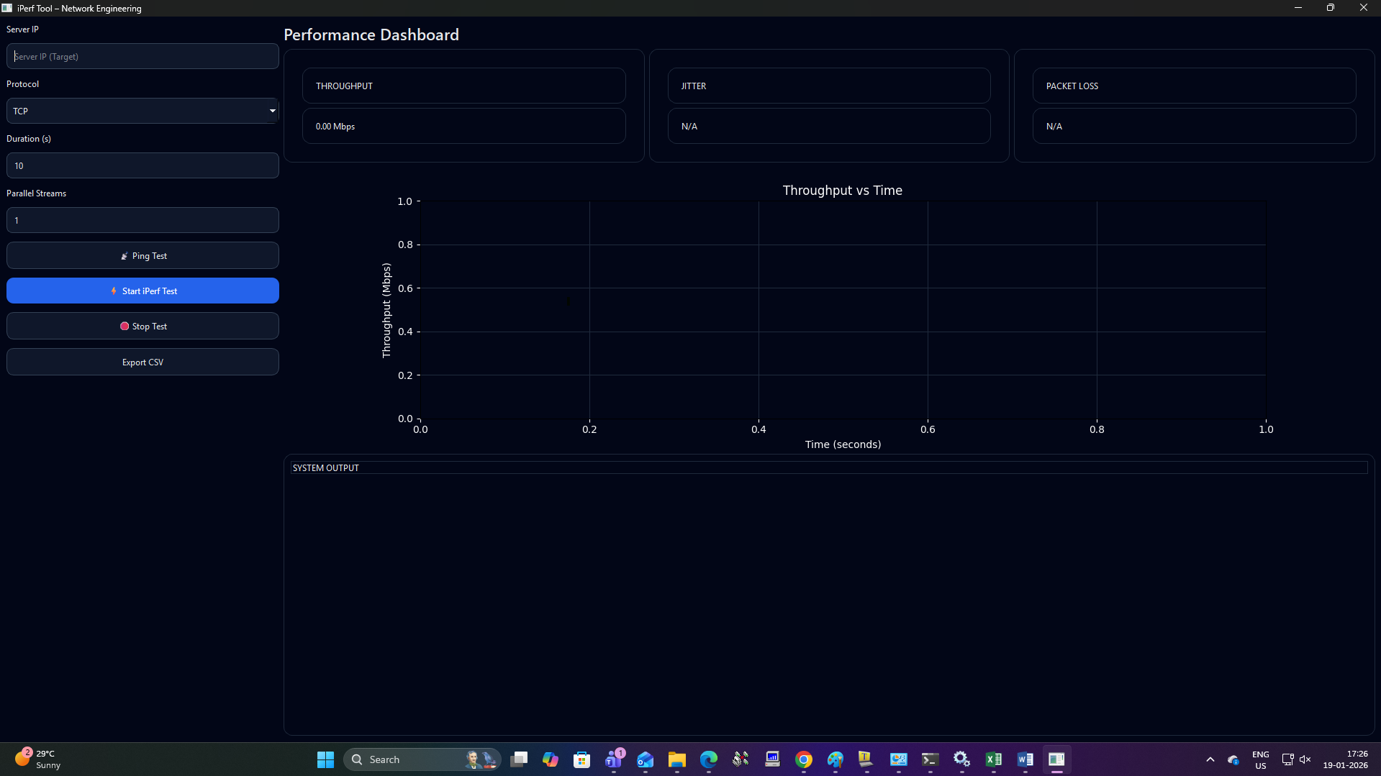

Let’s start with thee testcases –

- PING
Ping is a basic network utility used to test the reachability of a host (computer, server, or network device) over an IP network. It measures the round-trip time for packets sent from the source to the destination and back. Ping is widely used for network diagnostics, performance testing, and troubleshooting connectivity issues.
The name “Ping” comes from sonar terminology, where a pulse of sound is sent out and an echo is received, helping detect objects. In networking, a similar concept is applied using ICMP (Internet Control Message Protocol) Echo Request and Echo Reply packets.
This is the main dashboard where we enter the parameters-
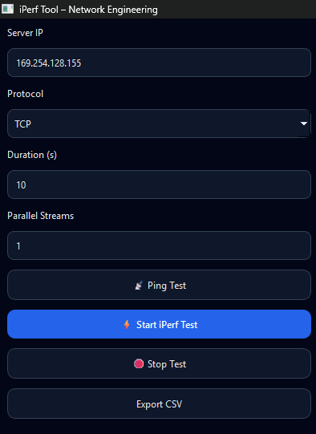
So we run this application in the client side so we need to always add the server ip address and then we can crosscheck the ping test in the Wireshark application in the server application.
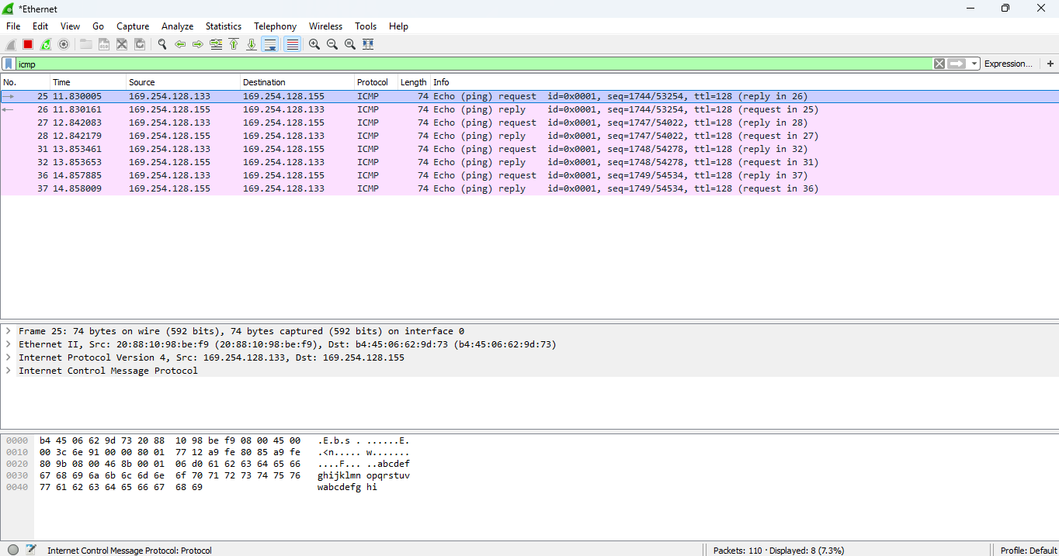

This is one way to confirm the ping test by default we have given ping test for four seconds .
When testing a network performance tool like a GUI-based iPerf application, Ping is often used as a preliminary check to ensure connectivity between the client and server. A failed ping may indicate that iPerf tests will also fail, or that additional network configuration is required. It helps in interpreting iPerf results, as high latency or packet loss detected by Ping can correlate with reduced throughput in iPerf tests.

How Ping Works
- Echo Request: The source device sends a small ICMP packet to the target IP address.
- Echo Reply: The target responds with an ICMP reply packet.
- TCP(Transmission control protocol)
TCP (Transmission Control Protocol) testing in iPerf is used to measure the reliable network throughput between a client and server over a TCP connection. TCP is a connection-oriented protocol, meaning it ensures ordered, error-checked delivery of data. Unlike UDP, which may drop packets, TCP guarantees that all data sent from the client reaches the server without loss or duplication, making it ideal for measuring maximum achievable bandwidth in a stable network environment.
iPerf allows users to perform TCP tests by establishing a TCP connection between the client and the server and transmitting data for a specified duration. During the test, iPerf calculates and reports important metrics such as throughput (bandwidth), transfer size, and transfer rate, providing insight into network performance under TCP traffic conditions.

Lets start with the tcp demonstration with single pair
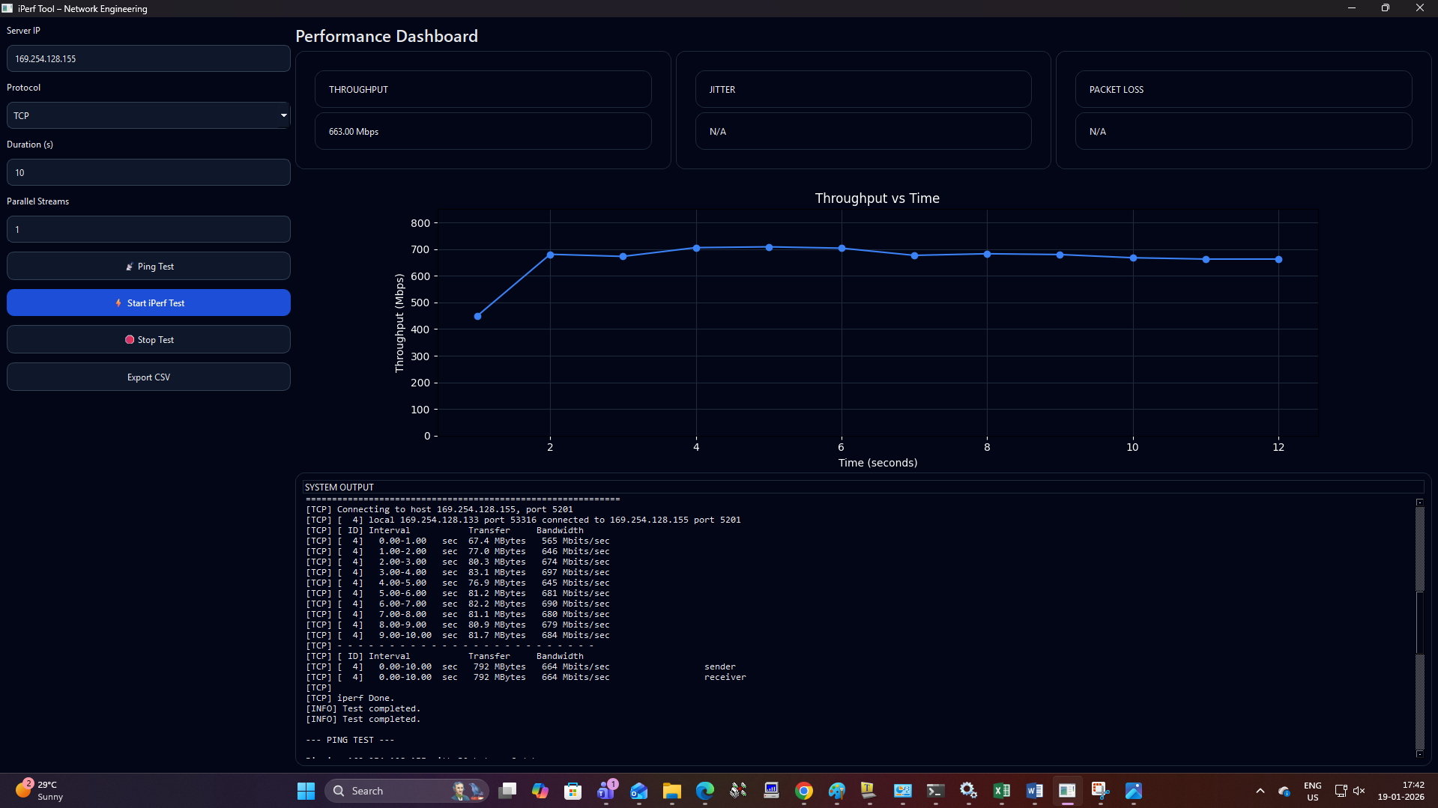

This is demonstration for TCP traffic testing using a single pair

Test Execution and System Output
- The test performed is a TCP throughput test between the local machine (169.254.128.133) and the server (169.254.128.155) on port 5201.
- Interval-by-interval throughput results are logged:
  - Each 1-second interval reports transfer size in MBytes and bandwidth in Mbits/sec.
  - Observed bandwidth values per second range roughly from 645 Mbps to 697 Mbps, showing stable throughput.
- Final summary:
  - Total data transferred: 792 MBytes in 10 seconds.
  - Average bandwidth: 664 Mbits/sec (both sender and receiver)
- Test completed successfully with no errors or retransmission warnings visible.

The average throughput recorded for the test was 664 Mbps, indicating a stable and reliable connection between the client and server. Since TCP guarantees ordered and reliable delivery, metrics such as jitter and packet loss were not applicable in this scenario, which is consistent with expectations for TCP-based network measurements.
The GUI provided a clear and user-friendly interface for configuring the test, including fields for server IP, protocol selection, duration, and number of parallel streams. Test control buttons allowed users to start, stop, and export results easily, while the real-time Throughput vs Time graph visualized performance fluctuations and trends throughout the test duration.
I have attached the proofs for to crosscheck in my server computer as well for tcp demonstration with single pair

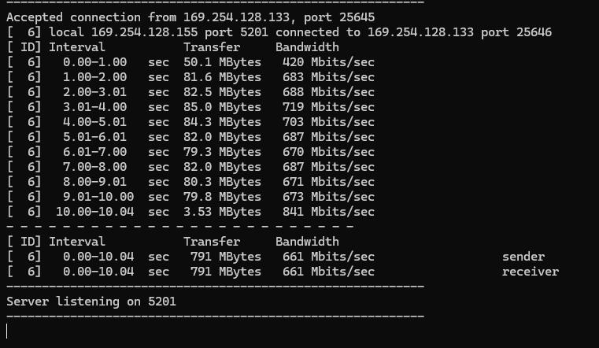

Lets start with the tcp demonstration with multiple pairs-

Overview of TCP Testing with Multiple Pairs
TCP testing with multiple pairs in iPerf involves creating multiple simultaneous TCP connections between the client and server to measure aggregate network throughput. Each pair (or stream) represents a separate TCP connection. This approach is useful for testing high-speed networks, where a single TCP connection may not fully utilize available bandwidth due to TCP flow control and congestion management. By using multiple streams, iPerf can generate higher overall throughput and better evaluate the network’s performance under heavy load.

Importance of Multi-Pair TCP Testing
- High-Speed Network Testing: Multiple streams can saturate high-bandwidth links where a single TCP connection is insufficient.
- Aggregate Throughput Measurement: Shows the total capacity of the network, not just a single connection’s performance.
- TCP Behavior Analysis: Helps identify congestion, packet loss, and retransmissions under higher network load.
- Scalability Testing: Useful to test how the network behaves with multiple simultaneous users or sessions.

I have taken here an example for three pairs TCP test

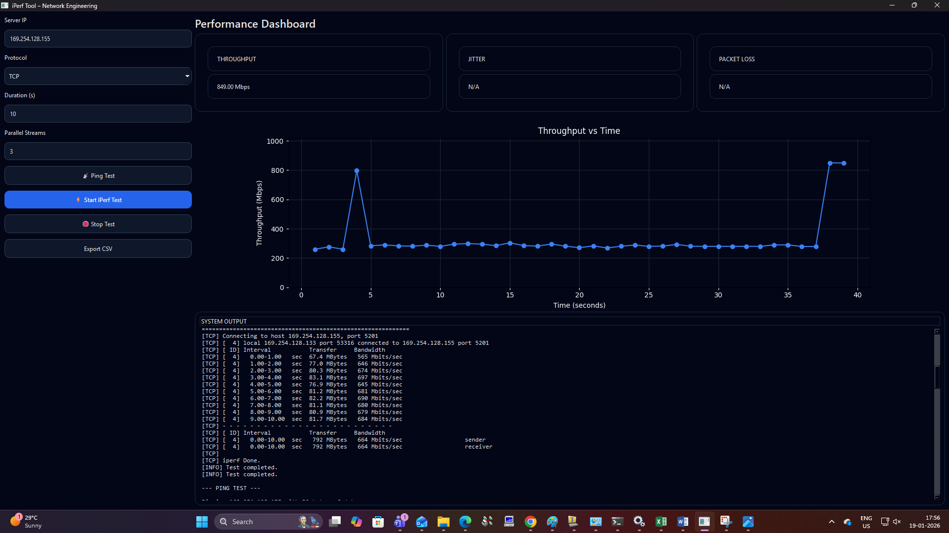

To cross check these I have also attached screenshots from server PC as well
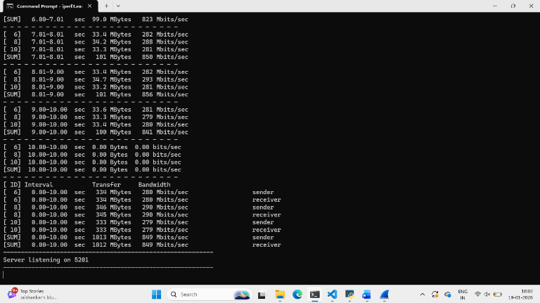

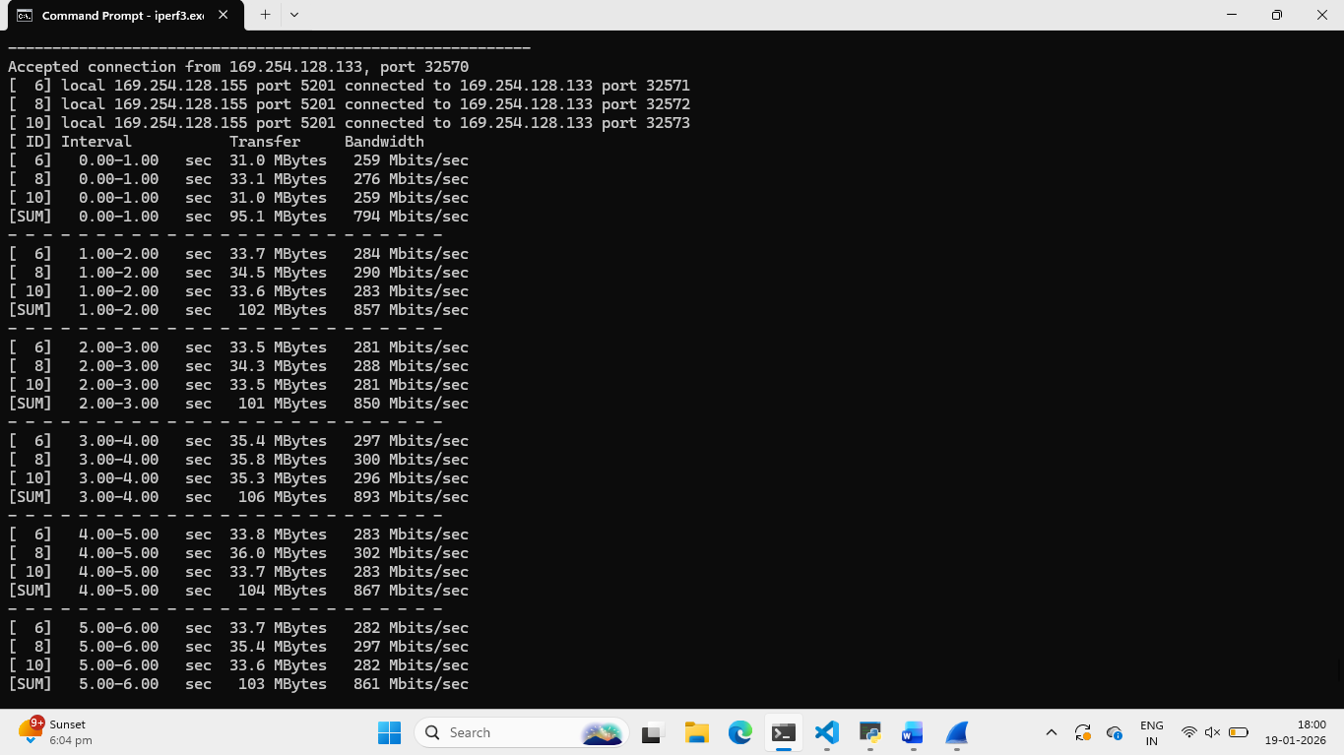

UDP(User data protocol)
UDP (User Datagram Protocol) testing in iPerf is used to measure network throughput, packet loss, and jitter over a connectionless protocol. Unlike TCP, UDP does not guarantee reliable delivery; packets may be lost, arrive out of order, or be duplicated. Because of this, UDP testing is particularly useful for evaluating network performance for real-time applications such as VoIP, video streaming, or gaming, where latency, jitter, and packet loss are critical factors.
When using UDP in iPerf:
- Server setup: iPerf runs in server mode and listens for incoming UDP traffic.
- Client setup: iPerf runs in client mode and sends UDP packets at a specified bandwidth.
- Statistics collection: At the end of the test, iPerf reports:
  - Bandwidth achieved
  - Packet loss percentage
  - Jitter
  - Number of datagrams sent/received

Lets start with performing udp test on single pair first

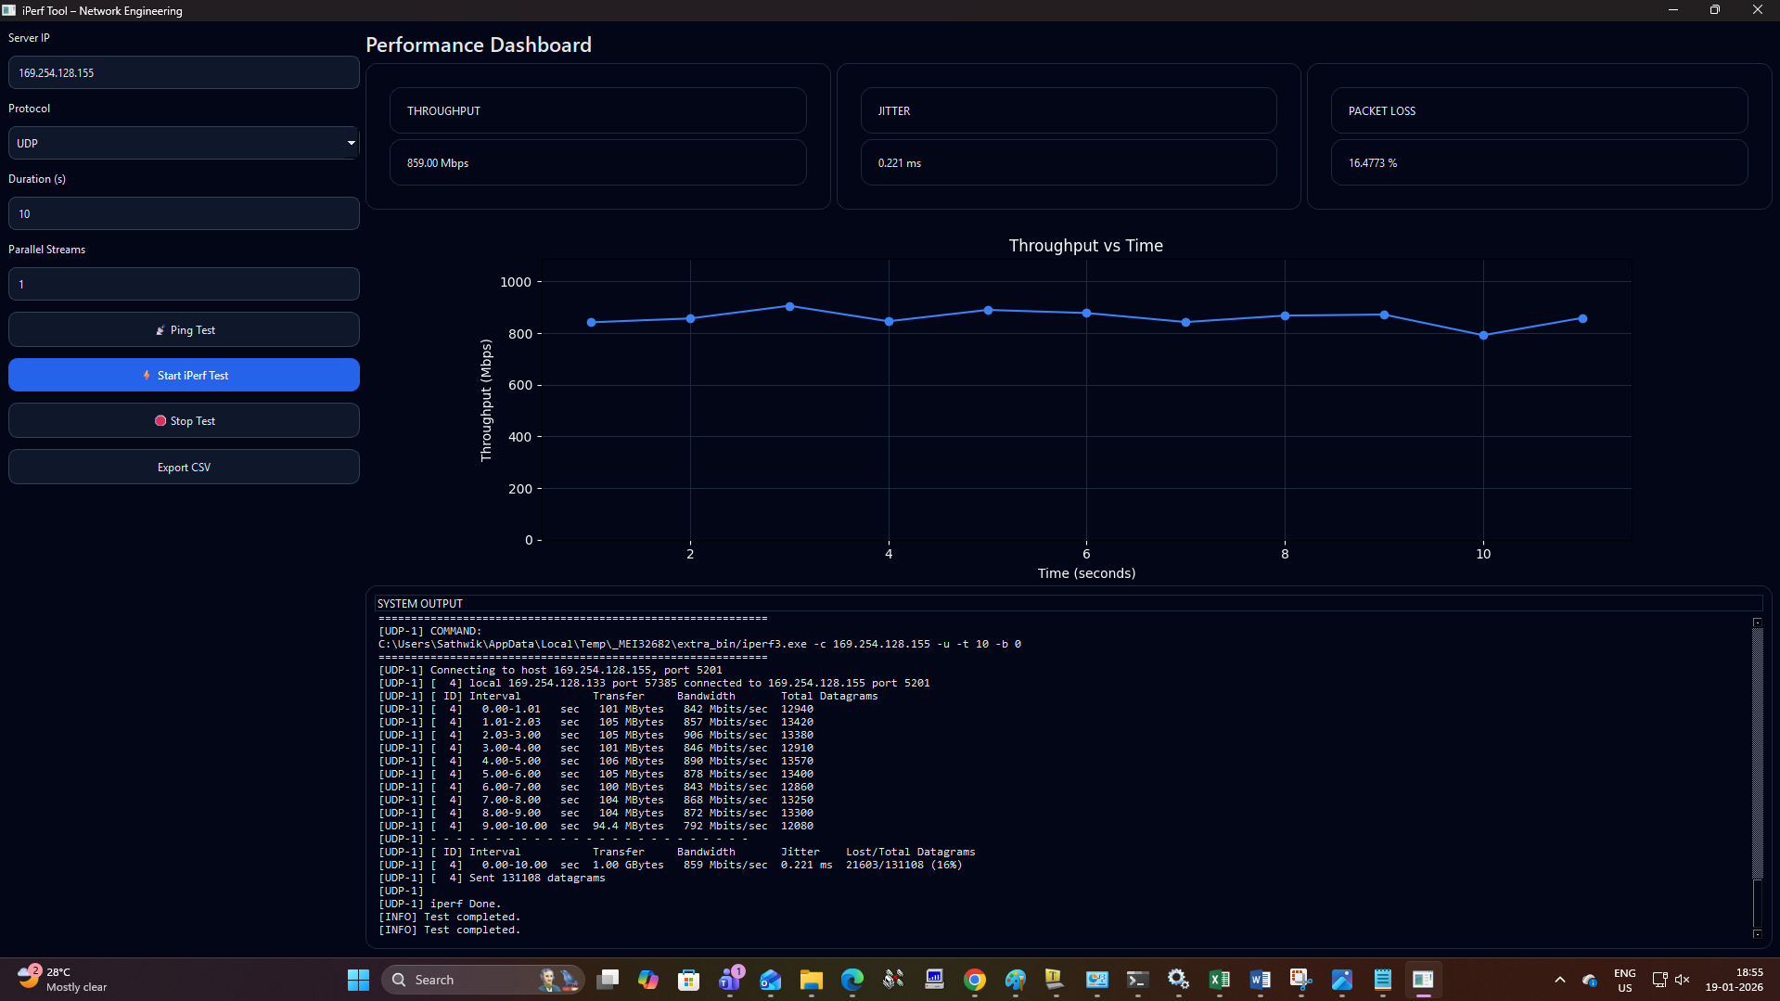

Test Setup (Left Panel)
- Server IP: 169.254.128.155
- Protocol: UDP
- Duration: 10 seconds
- Parallel Streams: 1
- Other Actions: Ping test option available, Start/Stop test, Export CSV

Performance Dashboard (Top Panel)
- Throughput: 859 Mbps
- Jitter: 0.221 ms
- Packet Loss: 16.4773%
Interpretation:
- The network can handle around 859 Mbps of UDP traffic.
- Jitter is very low (good for real-time traffic like VoIP/video).
- Packet loss is significant (~16%), indicating that the network is dropping a noticeable portion of UDP packets under this load.

Lets start with performing udp test on multiple pairs now
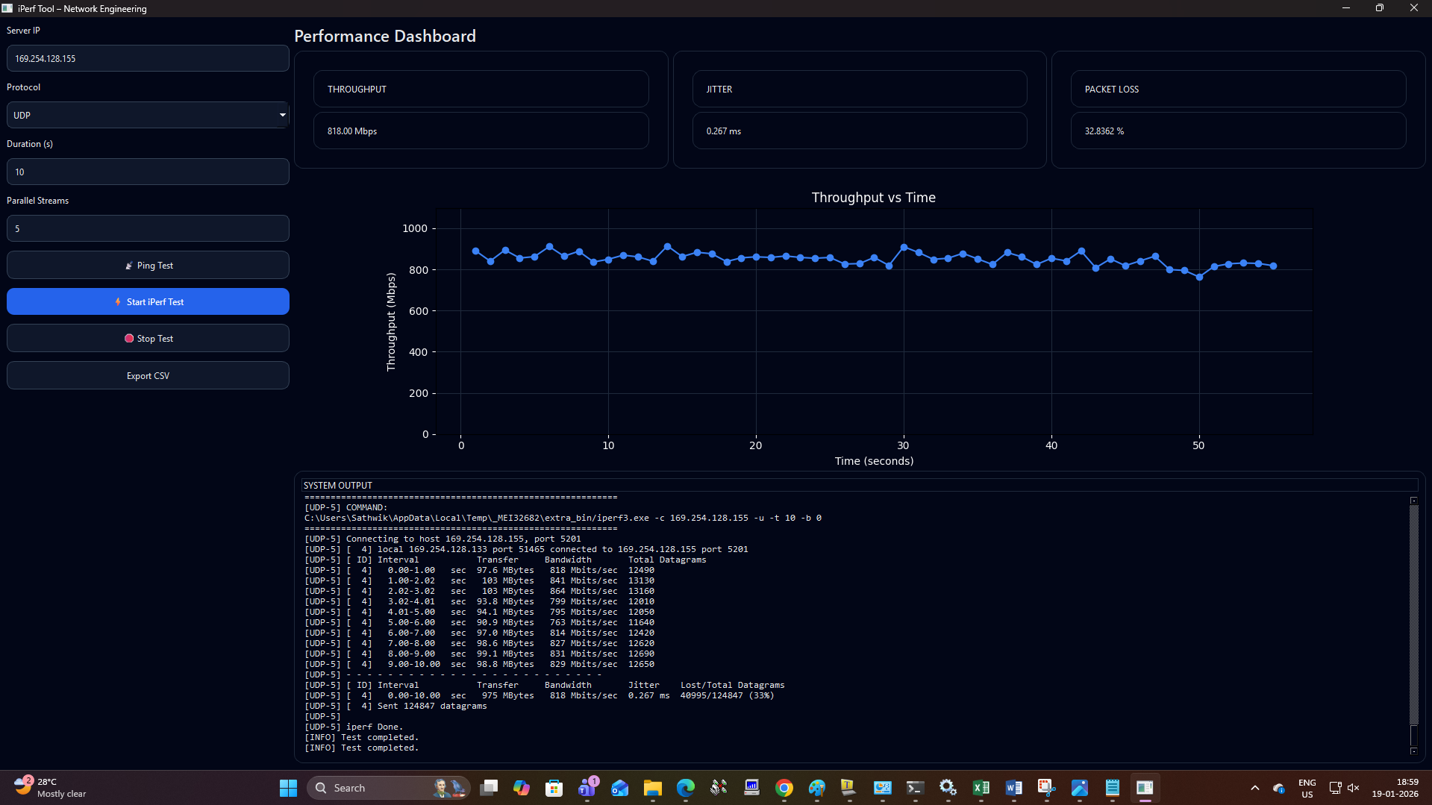
Lets cross check with the server pc
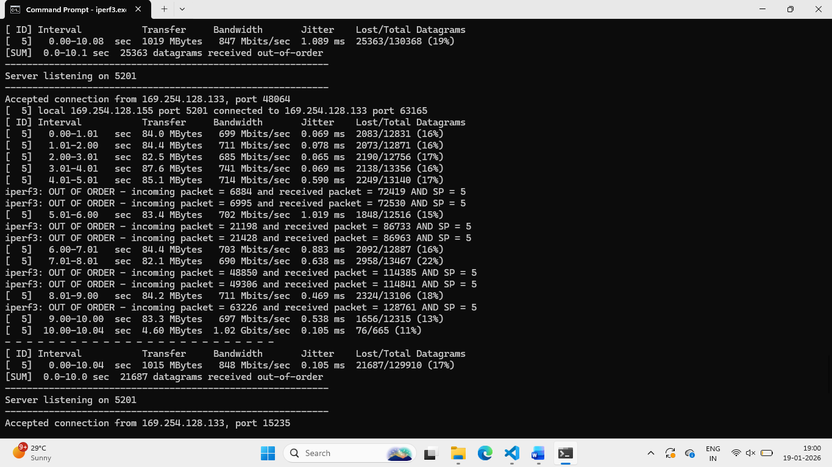
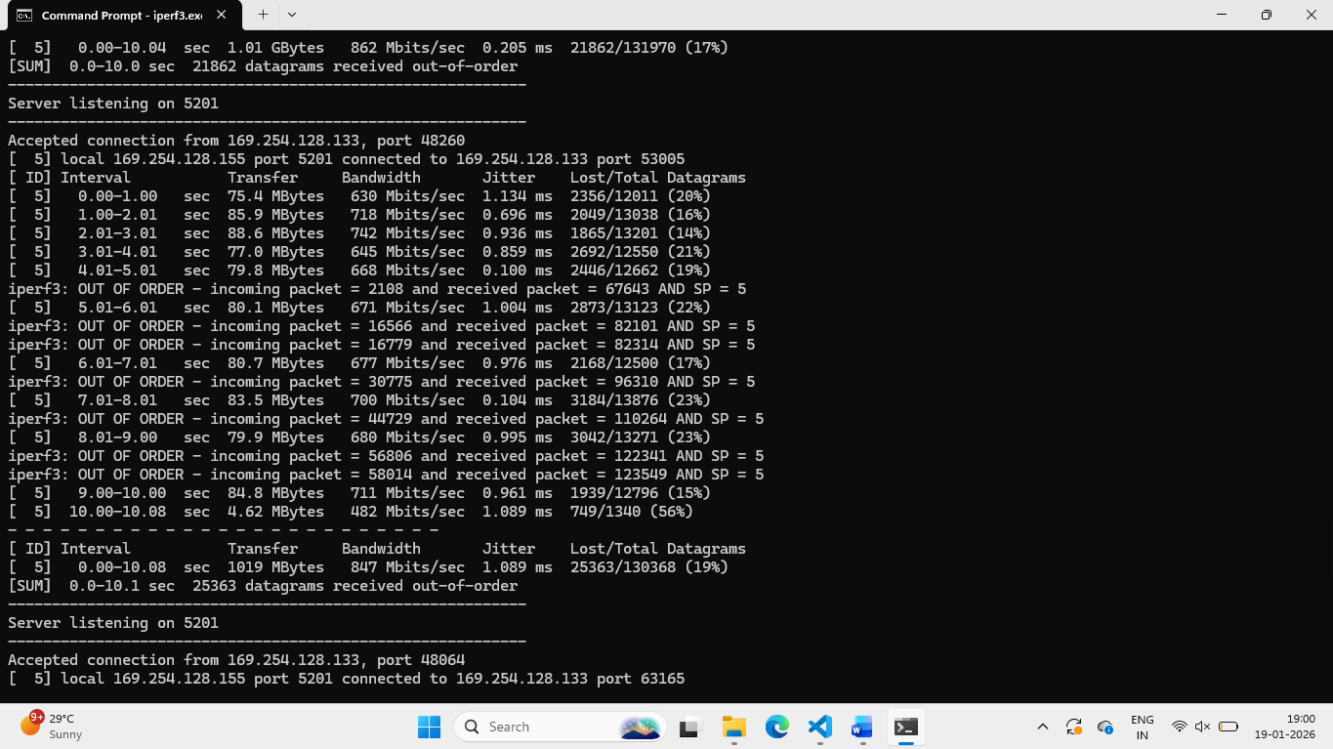

The iPerf GUI application provides a clear and user-friendly interface to perform network performance tests using both TCP and UDP protocols. The UDP testing feature effectively measures key metrics such as throughput, jitter, and packet loss, allowing users to assess network capacity and quality in real time. The performance dashboard and graphical representation of throughput over time make it easy to interpret results at a glance, while the detailed system output ensures transparency and precision. Overall, the application simplifies network testing, making it accessible for both beginners and network engineers.

